

monthly minutes of the meeting



2024-2026

Sangguniang Kabataan of Barangay Paligui

Paligui, Apalit, Pampanga

Republic of the Philippines

Region III

Province of Pampanga

Municipality of Apalit

**BARANGAY PALIGUI**

*Office of the Sangguniang Kabataan*

**Barangay Session 1**

**MINUTES OF THE MEETING**

Date: November 14, 2023

Time: 6:00 pm

**AGENDA:**

1. Planning
2. Appointment of SK Treasurer
3. Appointment of SK Secretary
4. Other matters

**NAME POSITION**

**Present:**

Hon. Arjay L. Saclao - SK Chairperson/

Presiding Officer

Hon. Paul C. Alfonso - SK Kagawad

Hon. Ervie R. Dizon - SK Kagawad

Hon. Angelo F. Umali - SK Kagawad

Hon. Chin Jean M. Meneses - SK Kagawad

Hon. Ian Jasper C. Villarico - SK Kagawad

Hon. Michaela Lorine R. Amparo - SK Kagawad

Hon. Karen B. Bautista - SK Kagawad

Mr. Kenneth D. Bautista - SK Secretary

Ms. Angel Mae B. Bautista - SK Treasurer

**Absent:**

ORDER OF THE MEETING

1. SILENT Prayer was conducted and lead by SK Secretary Kenneth D. Bautista before the meeting started at 6:00 pm in the evening.
2. SK Chairperson Arjay L. Saclao introduce the newly appointed SK Secretary and SK Treasurer
3. Planning for the Future Projects
4. Other matter
5. The preciding officer ajorned the meeting at 8:05 pm

Prepared by:

Mr. Kenneth D. Bautista

SK Secretary

Noted by:

Hon. Arjay L. Saclao

SK Chairperson

Republic of the Philippines

Region III

Province of Pampanga

Municipality of Apalit

**BARANGAY PALIGUI**

*Office of the Sangguniang Kabataan*

**Barangay Session 1**

**MINUTES OF THE MEETING   
(DOCUMENTATION)**

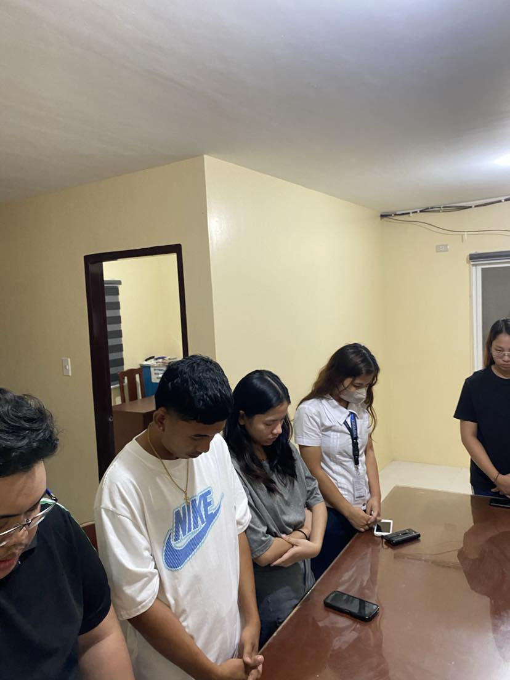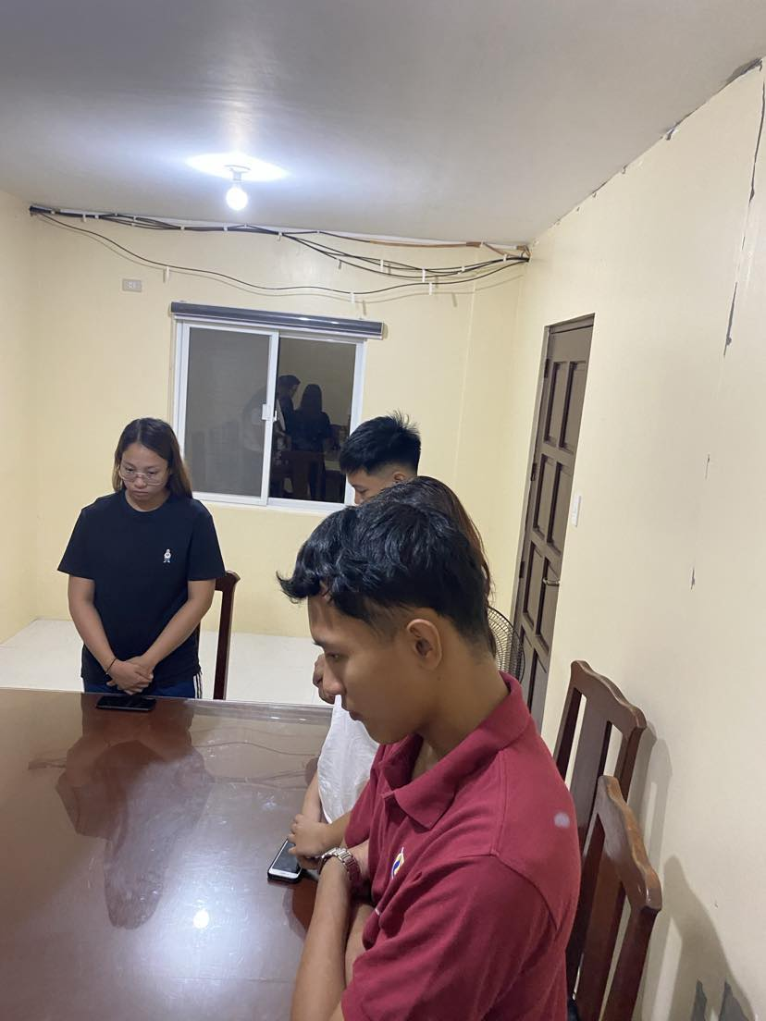

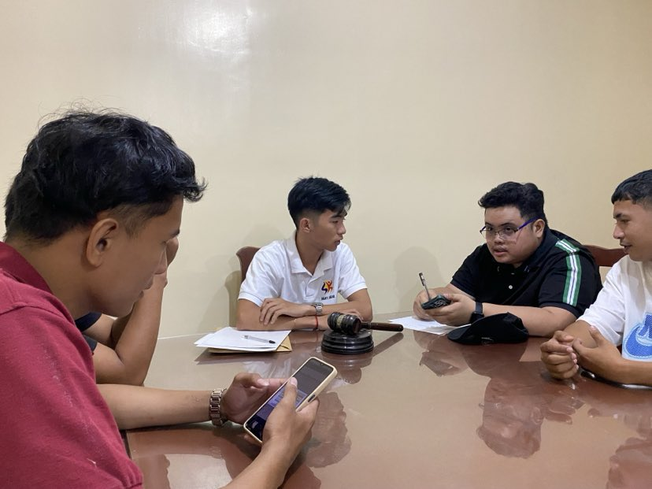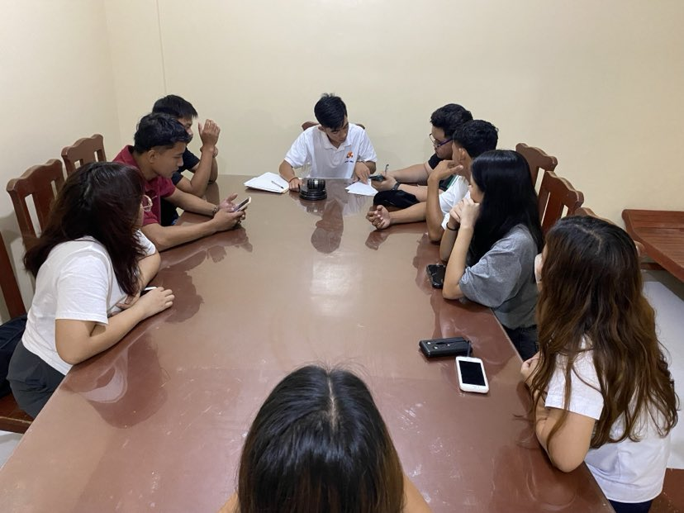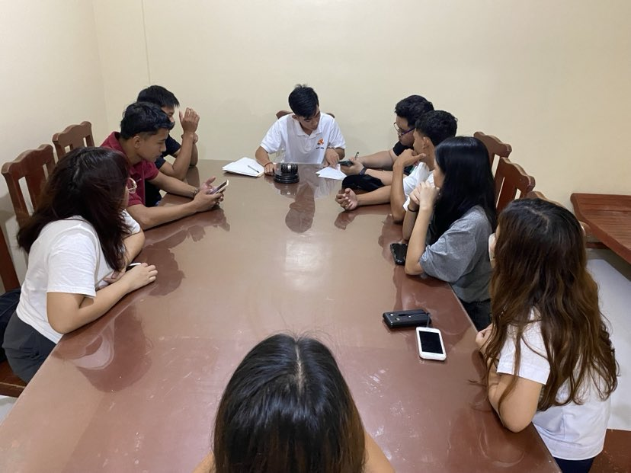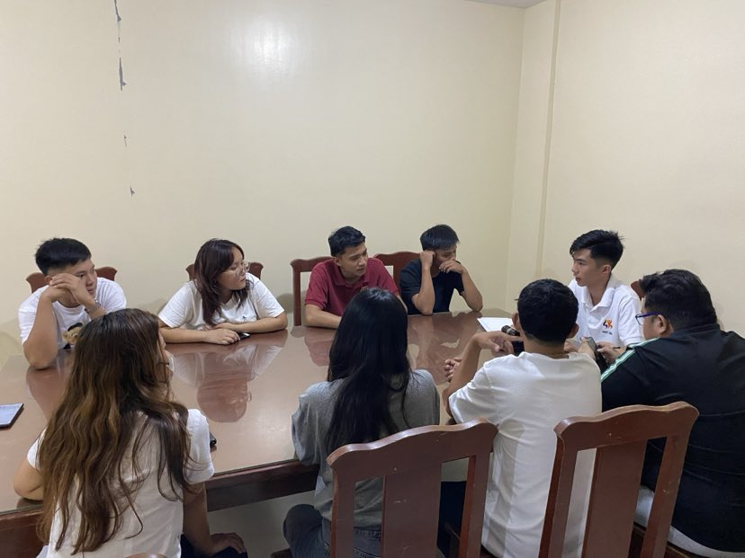

Republic of the Philippines

Region III

Province of Pampanga

Municipality of Apalit

**BARANGAY PALIGUI**

*Office of the Sangguniang Kabataan*

**Barangay Session 2**

**MINUTES OF THE MEETING**

Date: December 17, 2023

Time: 8:00 am

**AGENDA:**

1. Planning for ABYIP 2024
2. Planning for CBYDP 2024
3. Finalizing the appointment for the SK secretary and treasurer
4. Year End Palaro
5. Other matters

**NAME POSITION**

**Present:**

Hon. Arjay L. Saclao - SK Chairperson/

Presiding Officer

Hon. Paul C. Alfonso - SK Kagawad

Hon. Angelo F. Umali - SK Kagawad

Hon. Chin Jean M. Meneses - SK Kagawad

Hon. Ian Jasper C. Villarico - SK Kagawad

Hon. Michaela Lorine R. Amparo - SK Kagawad

Hon. Karen B. Bautista - SK Kagawad

Mr. Kenneth D. Bautista - SK Secretary

Ms. Angel Mae B. Bautista - SK Treasurer

**Absent:**

Hon. Ervie R. Dizon - SK Kagawad

ORDER OF THE MEETING

1. SILENT Prayer was conducterd and lead by SK Kagawad Angelo F. Umali before the meeting started at 8:00 am in the morning.
2. All of the Sk Members approve the appointment of the SK Treasurer and the Sk Secretary
3. SK Chairperson Arjay L. Saclao discuss the ABYIP and CBYDP
4. SK members are agreed to have a Year End Palaro at January 1, 2024
5. SK Members also initiated a plan and task dissemination for the year end palaro.
6. Other matter
7. The preciding officer ajorned the meeting at 10:15 am

Prepared by:

Mr. Kenneth D. Bautista

SK Secretary

Noted by:

Hon. Arjay L. Saclao

SK Chairperson

Republic of the Philippines

Region III

Province of Pampanga

Municipality of Apalit

**BARANGAY PALIGUI**

*Office of the Sangguniang Kabataan*

**Barangay Session 2**

**MINUTES OF THE MEETING   
(DOCUMENTATION)**

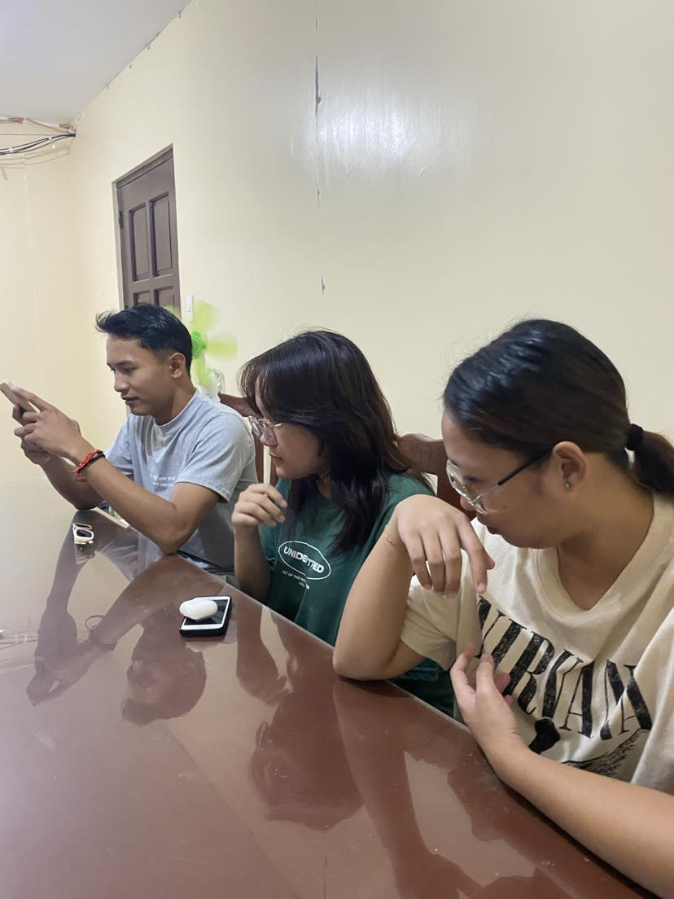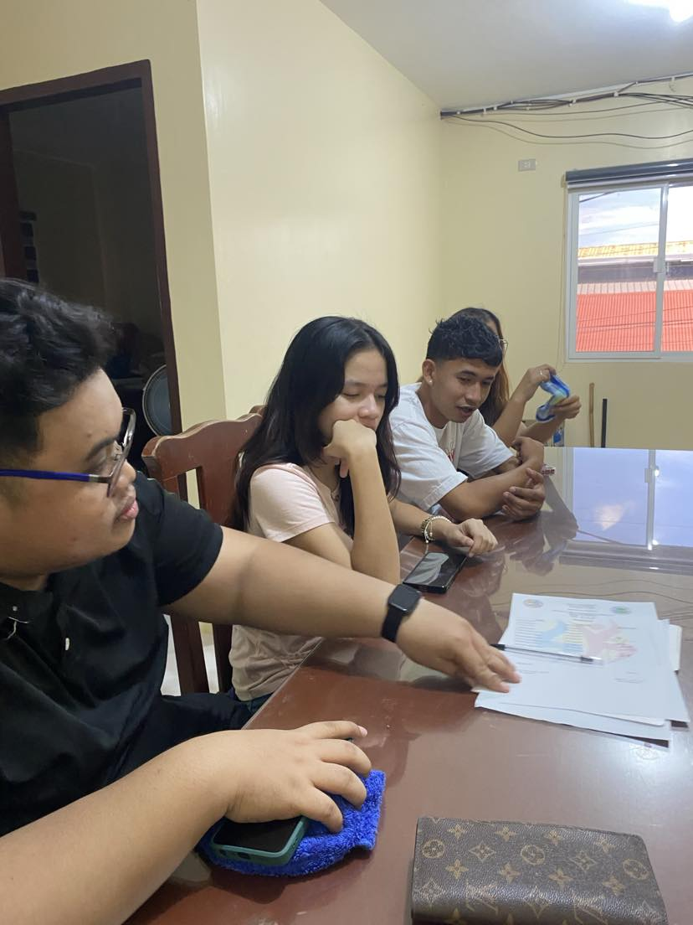

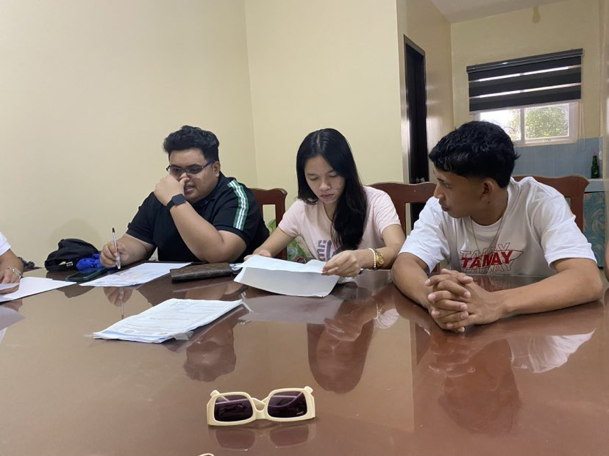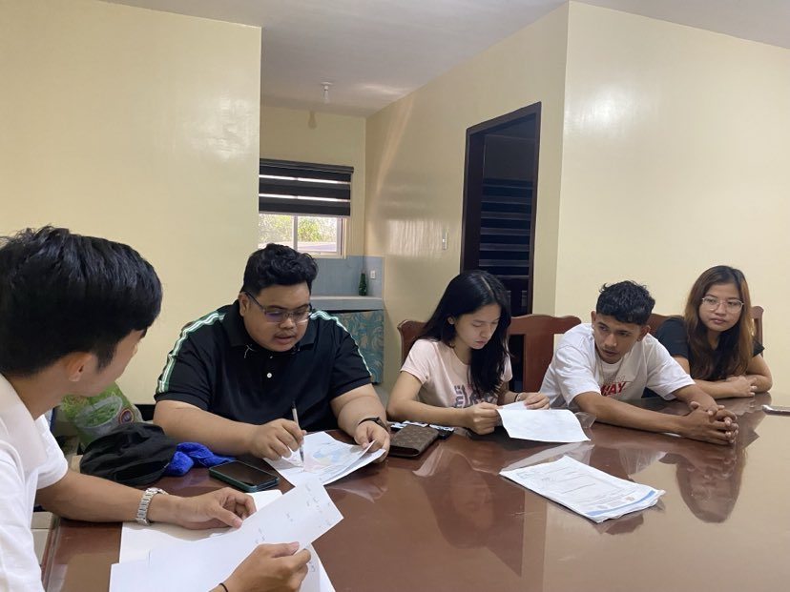

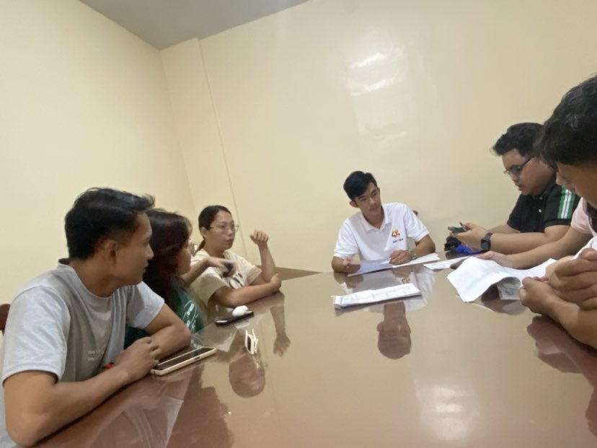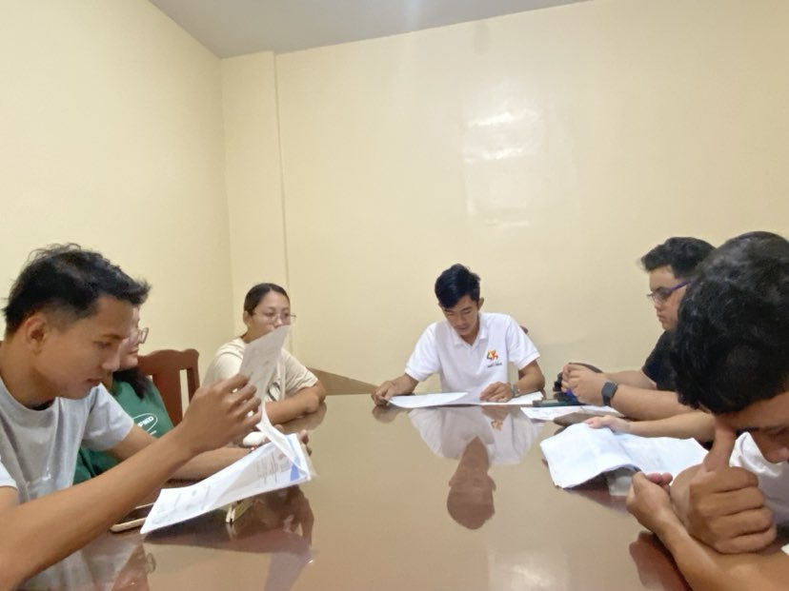

Republic of the Philippines

Region III

Province of Pampanga

Municipality of Apalit

**BARANGAY PALIGUI**

*Office of the Sangguniang Kabataan*

**Barangay Session 3**

**MINUTES OF THE MEETING**

Date: January 13, 2024

Time: 8:00 am

**AGENDA:**

1. Draftting of ABYIP 2024
2. Drafting of CBYDP 2024-2026
3. Planning for the incoming Inter-barkada basketball league 2024
4. Other matters

**NAME POSITION**

**Present:**

Hon. Arjay L. Saclao - SK Chairperson/

Presiding Officer

Hon. Paul C. Alfonso - SK Kagawad

Hon. Ervie R. Dizon - SK Kagawad

Hon. Angelo F. Umali - SK Kagawad

Hon. Chin Jean M. Meneses - SK Kagawad

Hon. Ian Jasper C. Villarico - SK Kagawad

Hon. Michaela Lorine R. Amparo - SK Kagawad

Hon. Karen B. Bautista - SK Kagawad

Mr. Kenneth D. Bautista - SK Secretary

Ms. Angel Mae B. Bautista - SK Treasurer

**Absent:**

ORDER OF THE MEETING

1. SILENT Prayer was conducted and lead by SK Kagawad Michaela Lorine R. Amparo before the meeting started at 8:am in the morning.
2. SK Secretary Kenneth D. Bautista and SK Treasurer Angel B. Bautista discuss the Initial draft of ABYIP and CBYDP
3. SK Chairperson Arjay L. Saclao with the SK Members discuss and plan the upcoming Interbarkada Basketball League.
4. The preciding officer ajorned the meeting at 11:00 am.

Prepared by:

Mr. Kenneth D. Bautista

SK Secretary

Noted by:

Hon. Arjay L. Saclao

SK Chairperson

Republic of the Philippines

Region III

Province of Pampanga

Municipality of Apalit

**BARANGAY PALIGUI**

*Office of the Sangguniang Kabataan*

**Barangay Session 3**

**MINUTES OF THE MEETING   
(DOCUMENTATION)**

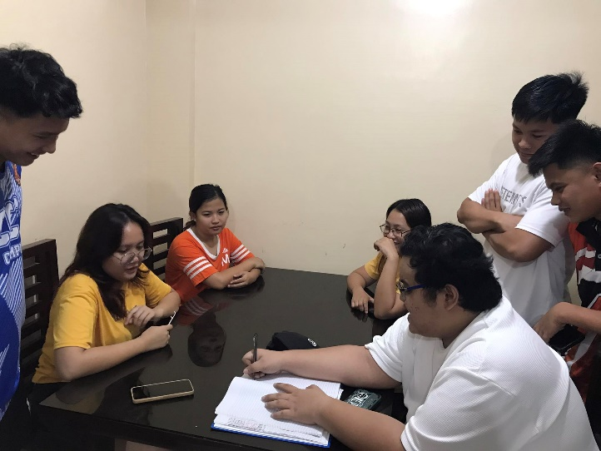

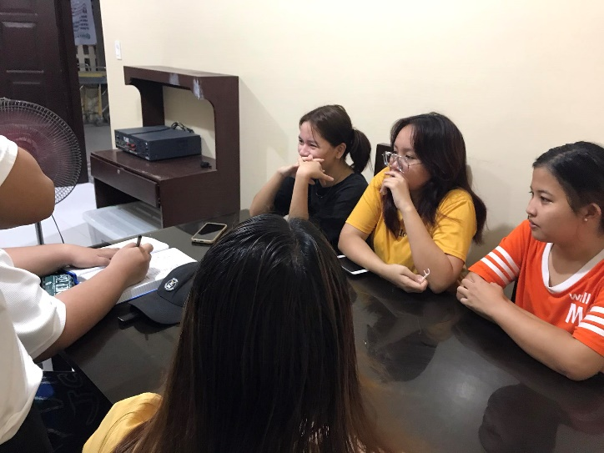

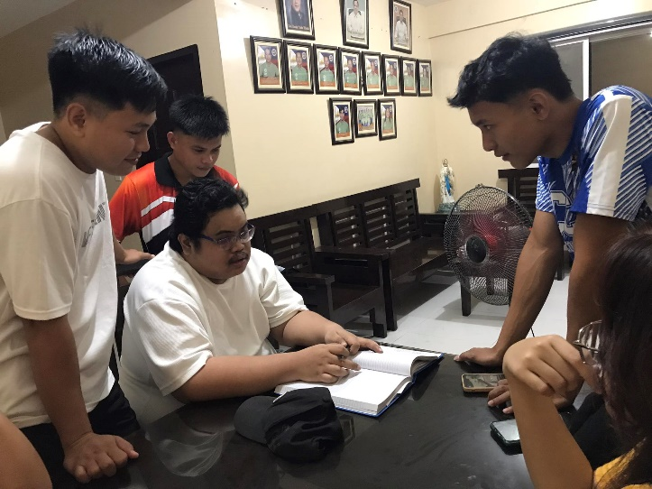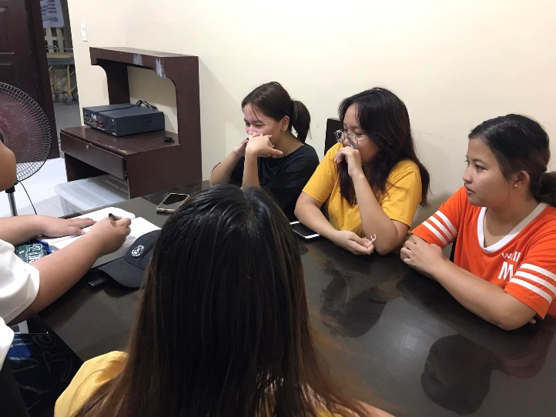

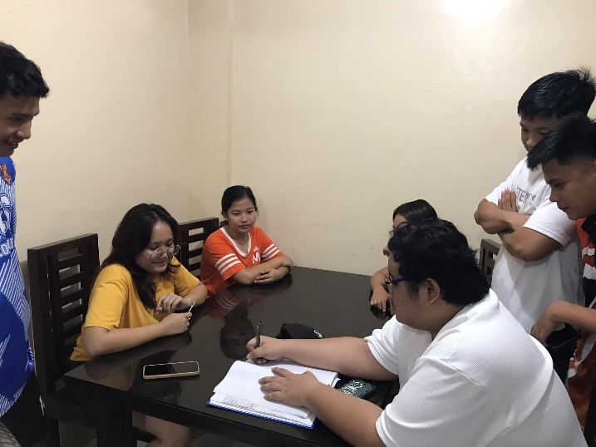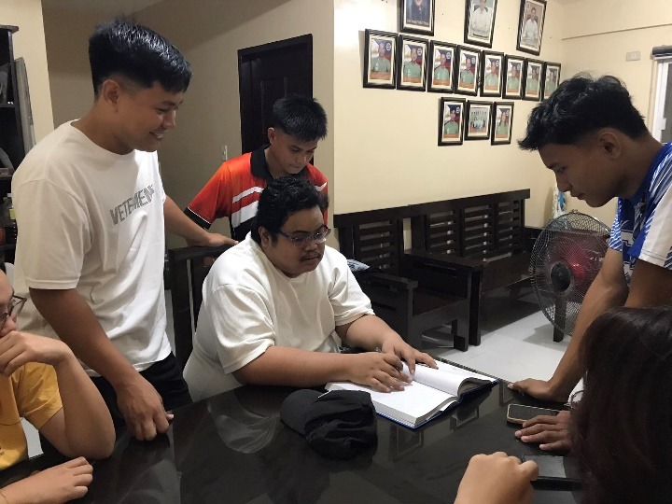

Republic of the Philippines

Region III

Province of Pampanga

Municipality of Apalit

**BARANGAY PALIGUI**

*Office of the Sangguniang Kabataan*

**Barangay Session 4**

**MINUTES OF THE MEETING**

Date: February 17, 2024

Time: 10:00 am

**AGENDA:**

1. Finalizing of CBYDP 2024-2026
2. Finalizing of ABYIP 2024
3. Task Dissemination for incoming inter-barkada basketball league preparation and opening day
4. Drafting of the Annual budget
5. Other matters

**NAME POSITION**

**Present:**

Hon. Arjay L. Saclao - SK Chairperson/

Presiding Officer

Hon. Paul C. Alfonso - SK Kagawad

Hon. Ervie R. Dizon - SK Kagawad

Hon. Angelo F. Umali - SK Kagawad

Hon. Chin Jean M. Meneses - SK Kagawad

Hon. Ian Jasper C. Villarico - SK Kagawad

Hon. Michaela Lorine R. Amparo - SK Kagawad

Hon. Karen B. Bautista - SK Kagawad

Mr. Kenneth D. Bautista - SK Secretary

Ms. Angel Mae B. Bautista - SK Treasurer

**Absent:**

ORDER OF THE MEETING

1. SILENT Prayer was conducted and lead by SK Treasurer Angel Mae B. Bautista before the meeting started at 10:00am in the morning.
2. SK Secretary Kenneth D. Bautista and SK Treasurer Angel Mae B. Bautista finalize the initial draft of CBYDP and ABYIP in front with the SK Members and SK Chairperson Arjay L. Saclao.
3. SK Chairperson Arjay L. Saclao together with SK Kagawad Paul C. Alfonso the head in Sports Committee, disseminate the task for the preparation of the upcoming Interbarkada Basketball League.
4. SK Treasurer Angel Mae B. Bautista discuss the SK Annual Budget.
5. Other Matters
6. The preciding officer ajorned the meeting at 1:20 pm.

Prepared by:

Mr. Kenneth D. Bautista

SK Secretary

Noted by:

Hon. Arjay L. Saclao

SK Chairperson

Republic of the Philippines

Region III

Province of Pampanga

Municipality of Apalit

**BARANGAY PALIGUI**

*Office of the Sangguniang Kabataan*

**Barangay Session 4**

**MINUTES OF THE MEETING   
(DOCUMENTATION)**

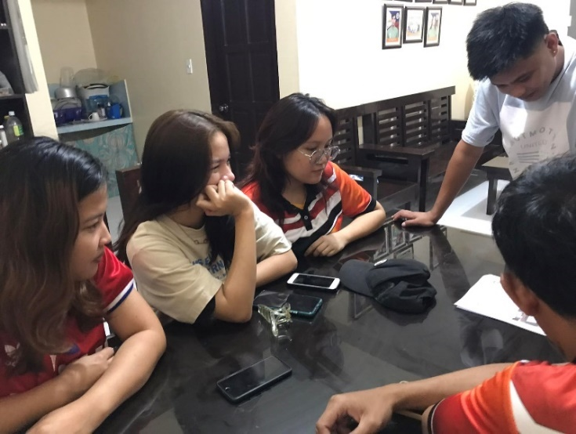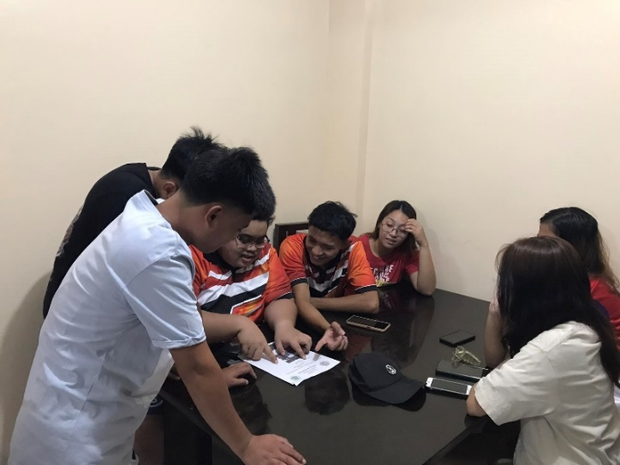

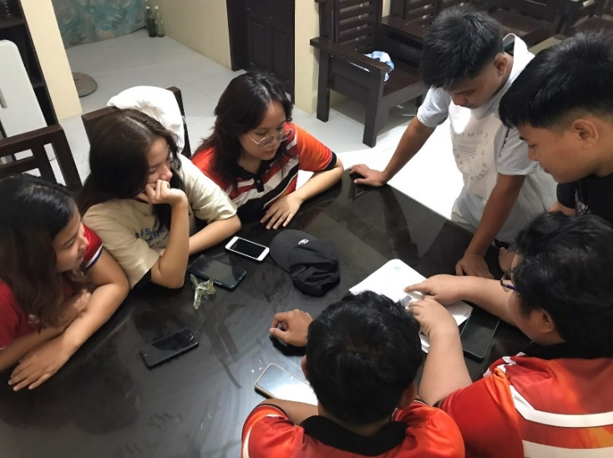

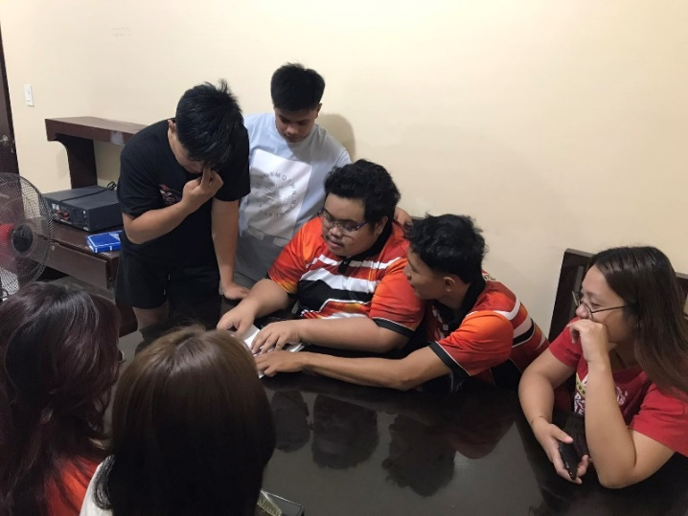

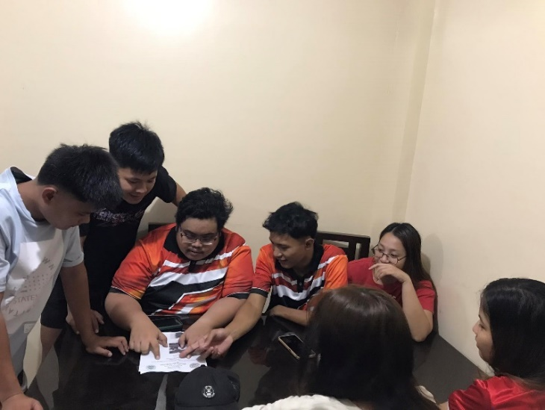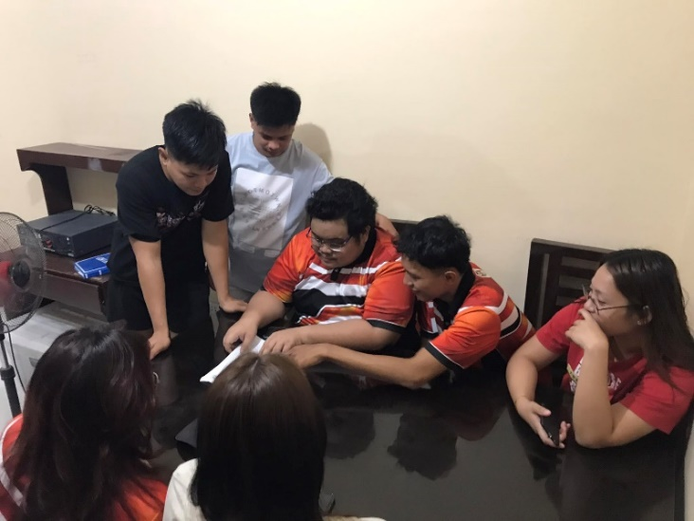

Republic of the Philippines

Region III

Province of Pampanga

Municipality of Apalit

**BARANGAY PALIGUI**

*Office of the Sangguniang Kabataan*

**Barangay Session 5**

**MINUTES OF THE MEETING**

Date: March 17, 2024

Time: 5:00 pm

**AGENDA:**

1. Finalizing of the Annual Budget
2. Planning for the incoming MJDT’s Cup 2024
3. Planning for the incoming SK Educational Assistance 2024
4. Other matters

**NAME POSITION**

**Present:**

Hon. Arjay L. Saclao - SK Chairperson/

Presiding Officer

Hon. Paul C. Alfonso - SK Kagawad

Hon. Ervie R. Dizon - SK Kagawad

Hon. Angelo F. Umali - SK Kagawad

Hon. Chin Jean M. Meneses - SK Kagawad

Hon. Ian Jasper C. Villarico - SK Kagawad

Hon. Michaela Lorine R. Amparo - SK Kagawad

Hon. Karen B. Bautista - SK Kagawad

Mr. Kenneth D. Bautista - SK Secretary

Ms. Angel Mae B. Bautista - SK Treasurer

**Absent:**

ORDER OF THE MEETING

1. SILENT Prayer was conducted and lead by SK Treasurer Angel Mae B. Bautista before the meeting started at 10:00am in the morning.
2. SK Treasurer Angel Mae B. Bautista finalize the SK Annual Budget together with the SK Members and SK Chairperson Arjay L. Saclao.
3. SK Chairperson Arjay L. Saclao together with the SK Members discuss the details in preparation for the upcoming MJDT’s Cup.
4. SK Kagawad Michaela Lorine R. Amparo head of Education Committee discuss the required requirements for the preparation of the upcoming distribution of Educational Assistance.
5. Other Matters.
6. The preciding officer ajorned the meeting at 7:00 pm.

Prepared by:

Mr. Kenneth D. Bautista

SK Secretary

Noted by:

Hon. Arjay L. Saclao

SK Chairperson

Republic of the Philippines

Region III

Province of Pampanga

Municipality of Apalit

**BARANGAY PALIGUI**

*Office of the Sangguniang Kabataan*

**Barangay Session 5**

**MINUTES OF THE MEETING   
(DOCUMENTATION)**

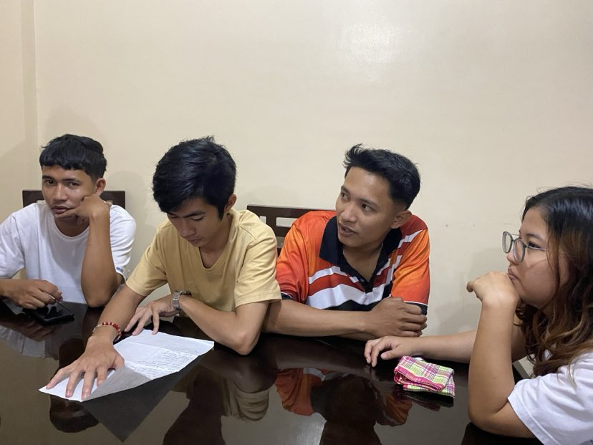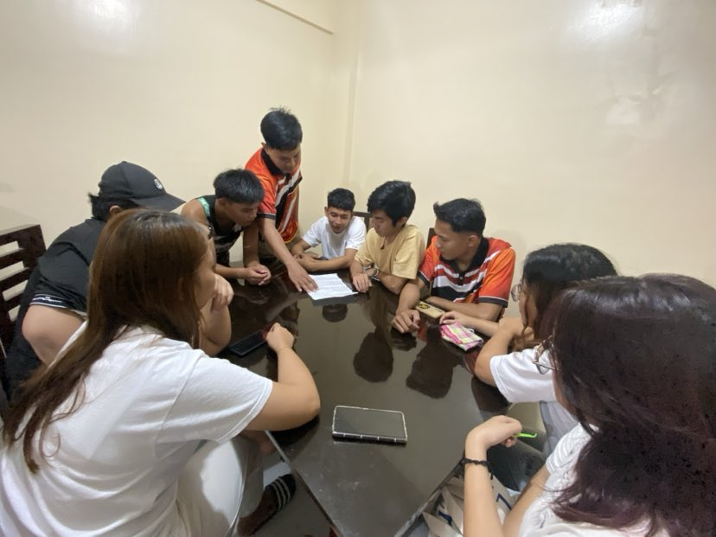

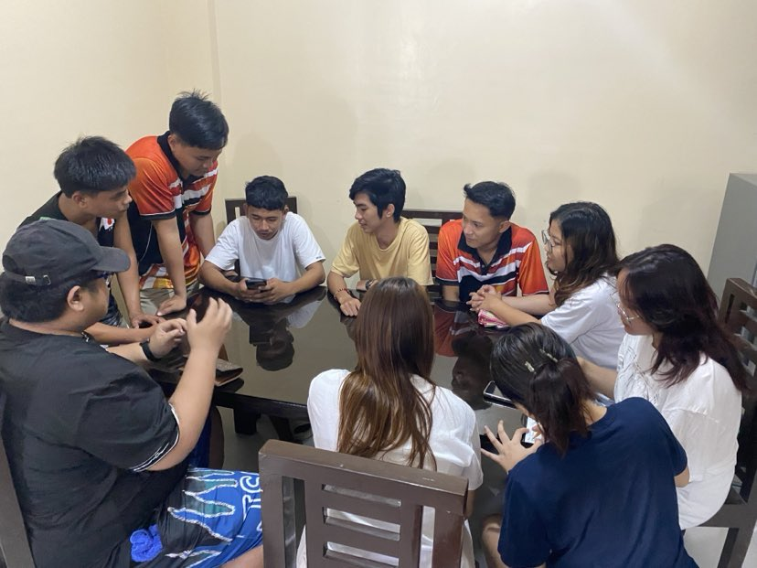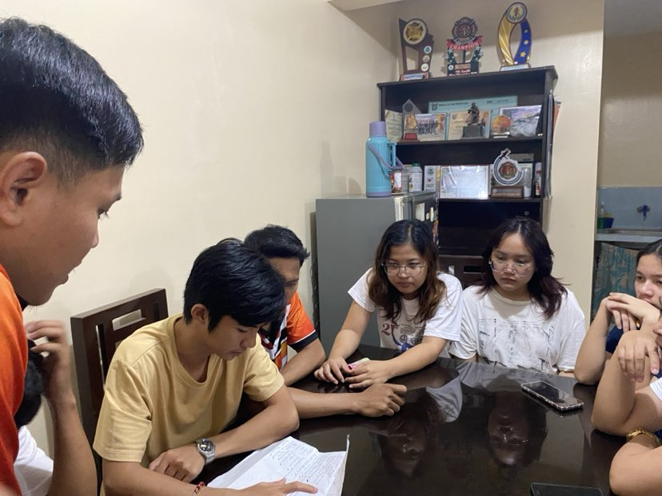

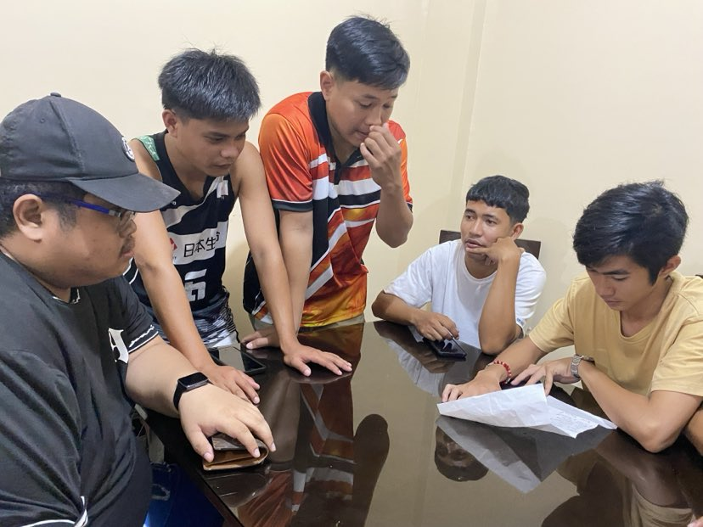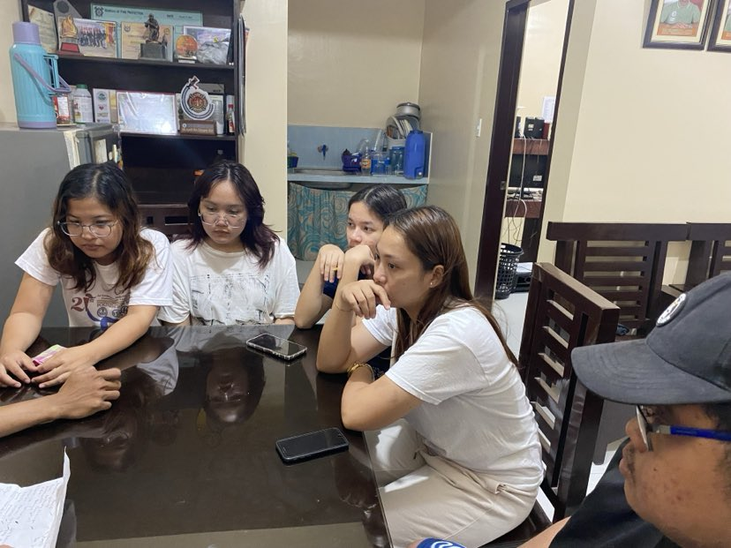

Republic of the Philippines

Region III

Province of Pampanga

Municipality of Apalit

**BARANGAY PALIGUI**

*Office of the Sangguniang Kabataan*

**Barangay Session 6**

**MINUTES OF THE MEETING**

Date: April 14, 2024

Time: 10:00 am

**AGENDA:**

1. Updates from the current projects
2. Finalizing of the Educational Assistance
3. Preparation for the incoming MJDT’s Cup 2024
4. Other matters

**NAME POSITION**

**Present:**

Hon. Arjay L. Saclao - SK Chairperson/

Presiding Officer

Hon. Paul C. Alfonso - SK Kagawad

Hon. Ervie R. Dizon - SK Kagawad

Hon. Chin Jean M. Meneses - SK Kagawad

Hon. Ian Jasper C. Villarico - SK Kagawad

Hon. Michaela Lorine R. Amparo - SK Kagawad

Hon. Karen B. Bautista - SK Kagawad

Mr. Kenneth D. Bautista - SK Secretary

Ms. Angel Mae B. Bautista - SK Treasurer

**Absent:**

Hon. Angelo F. Umali - SK Kagawad

ORDER OF THE MEETING

1. SILENT Prayer was conducted and lead by SK Kagawad Karen Joy B. Bautista before the meeting started at 10:00am in the morning.
2. SK Chairperson Arjay L. Saclao and other head committees discuss the current projects.
3. SK Kagawad Michaela Lorine R. Amparo head of education committee, finalize the requirements for the upcoming Educational Assistance.
4. Other Matters.
5. The preciding officer ajorned the meeting at 1:10 pm

Prepared by:

Mr. Kenneth D. Bautista

SK Secretary

Noted by:

Hon. Arjay L. Saclao

SK Chairperson

Republic of the Philippines

Region III

Province of Pampanga

Municipality of Apalit

**BARANGAY PALIGUI**

*Office of the Sangguniang Kabataan*

**Barangay Session 6**

**MINUTES OF THE MEETING   
(DOCUMENTATION)**

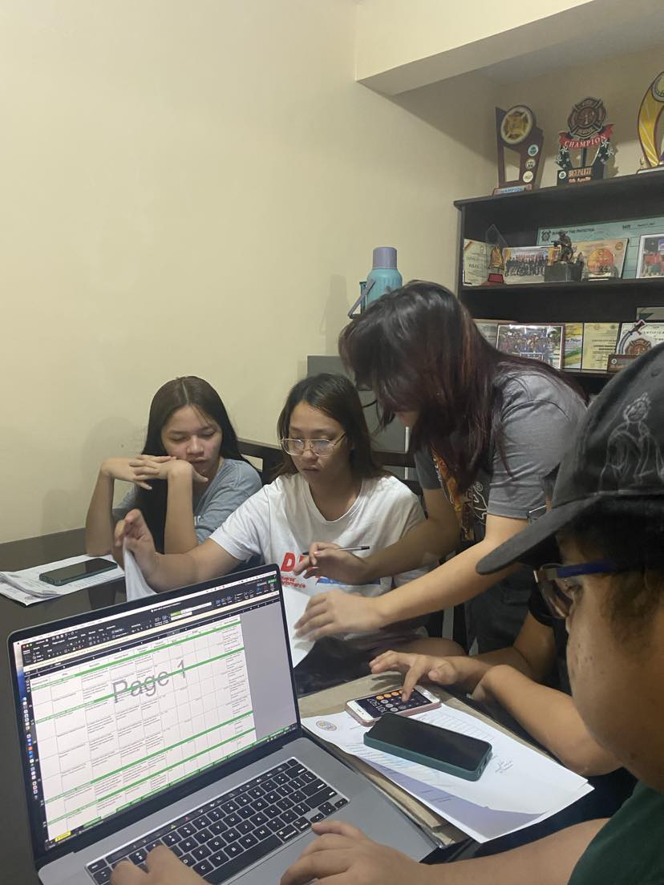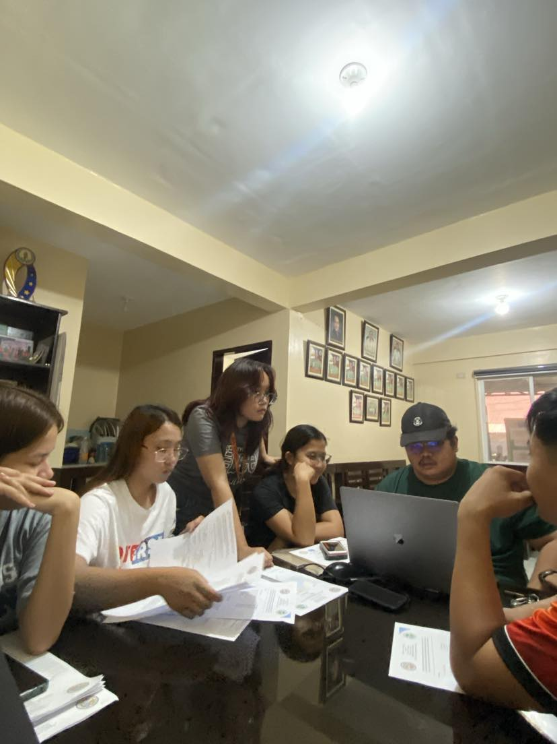

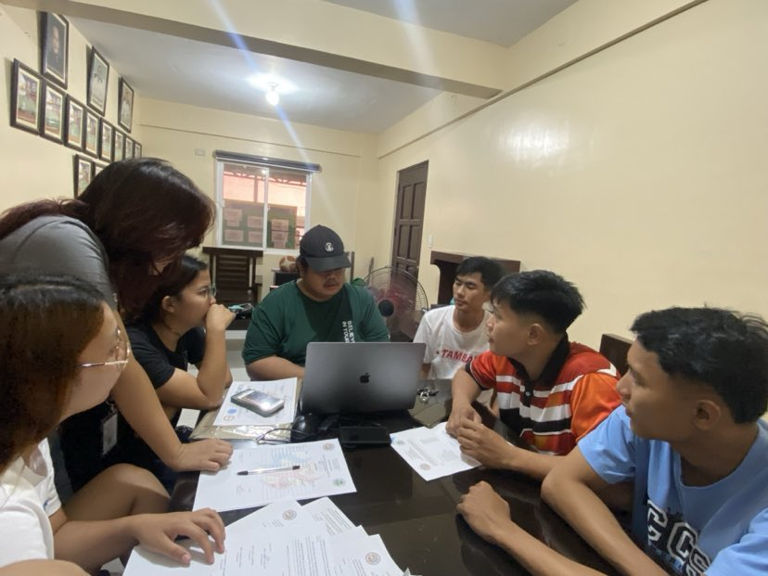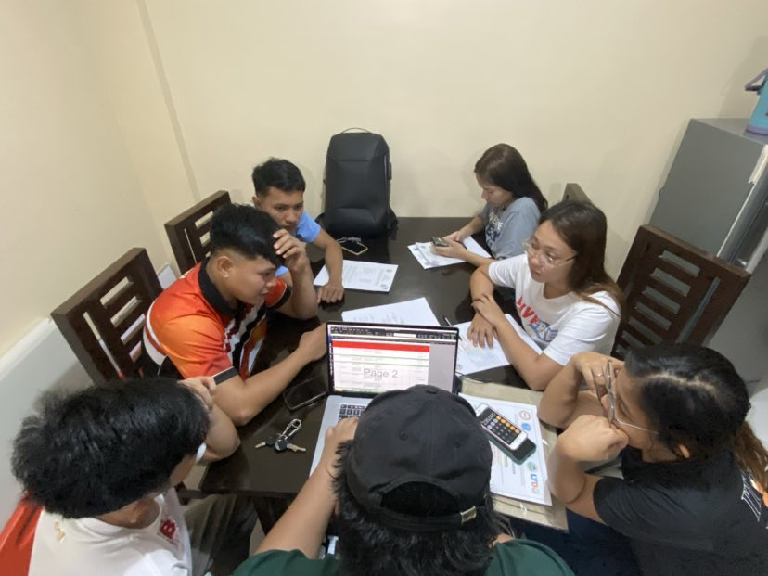

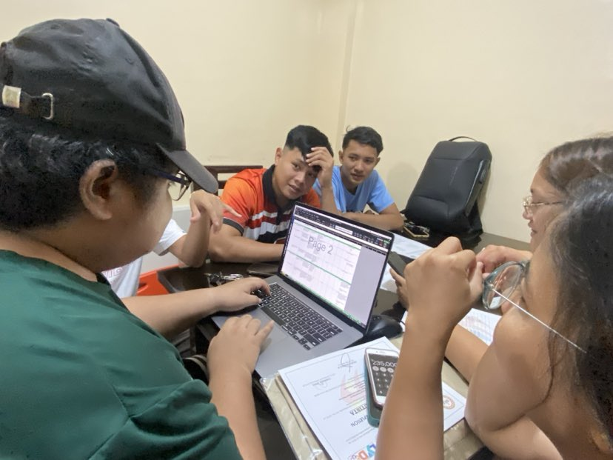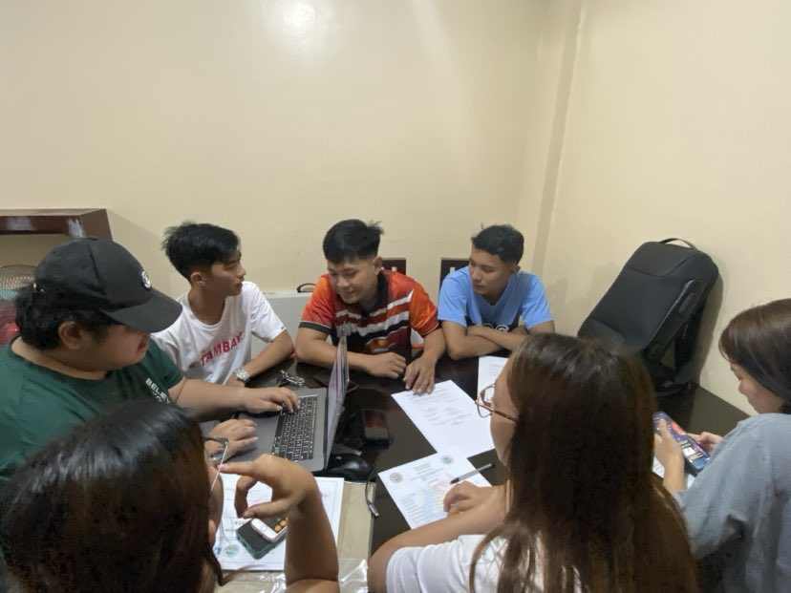

Republic of the Philippines

Region III

Province of Pampanga

Municipality of Apalit

**BARANGAY PALIGUI**

*Office of the Sangguniang Kabataan*

**Barangay Session 7**

**MINUTES OF THE MEETING**

Date: May 12, 2024

Time: 5:00 pm

**AGENDA:**

1. Updates for Educational Assistance
2. Updates for Miss Apalit and Street Dance
3. Financial Transaction for the SK Seminar
4. Updates for the Inter-Barkada Basketball league
5. Other matters

**NAME POSITION**

**Present:**

Hon. Arjay L. Saclao - SK Chairperson/

Presiding Officer

Hon. Paul C. Alfonso - SK Kagawad

Hon. Ervie R. Dizon - SK Kagawad

Hon. Angelo F. Umali - SK Kagawad

Hon. Chin Jean M. Meneses - SK Kagawad

Hon. Ian Jasper C. Villarico - SK Kagawad

Hon. Michaela Lorine R. Amparo - SK Kagawad

Hon. Karen B. Bautista - SK Kagawad

Mr. Kenneth D. Bautista - SK Secretary

Ms. Angel Mae B. Bautista - SK Treasurer

**Absent:**

ORDER OF THE MEETING

1. SILENT Prayer was conducted and lead by SK Kagawad Ervie R. Dizon before the meeting started at 5:00 pm in the afternoon.
2. Sk Secretary Kenneth D. Bautista discuss the Expenses for the Month of January – May..
3. Other matters
4. The preciding officer ajorned the meeting at 7:48 pm.

Prepared by:

Mr. Kenneth D. Bautista

SK Secretary

Noted by:

Hon. Arjay L. Saclao

SK Chairperson

Republic of the Philippines

Region III

Province of Pampanga

Municipality of Apalit

**BARANGAY PALIGUI**

*Office of the Sangguniang Kabataan*

**Barangay Session 7**

**MINUTES OF THE MEETING   
(DOCUMENTATION)**

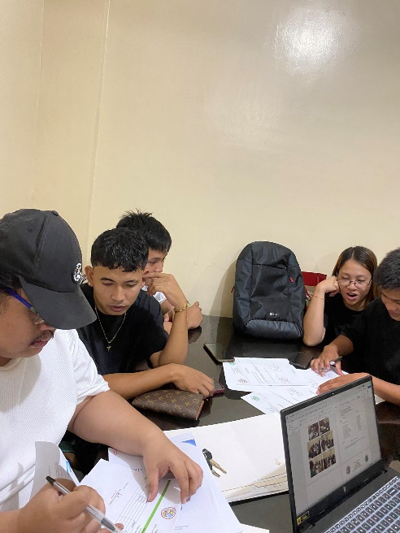

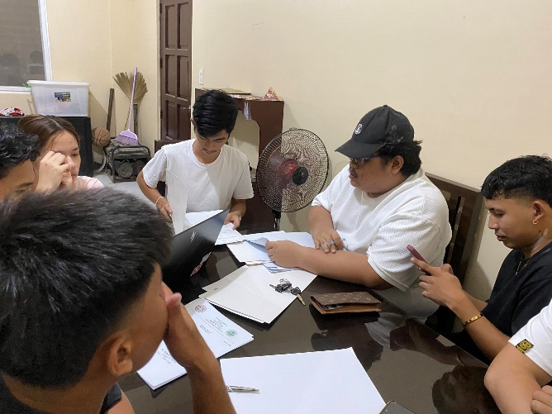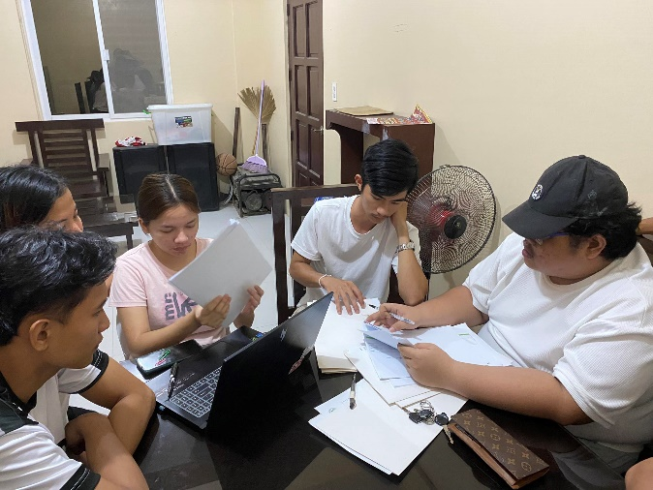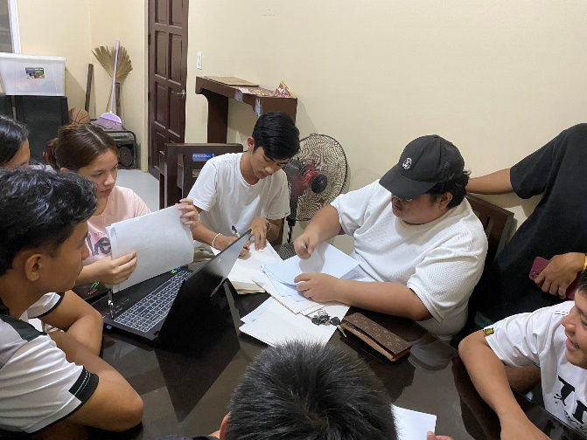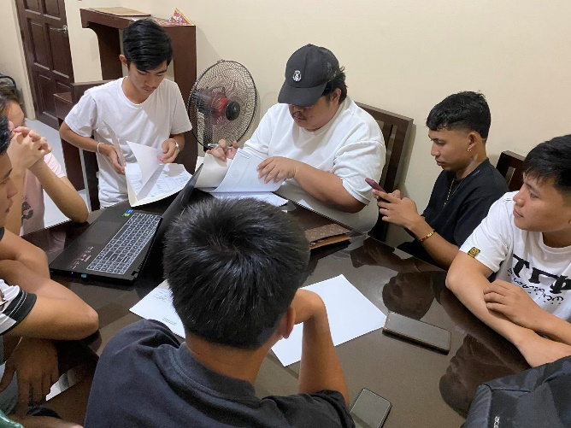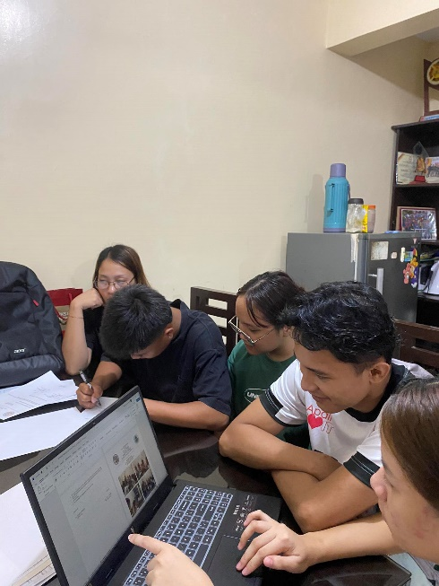

Republic of the Philippines

Region III

Province of Pampanga

Municipality of Apalit

**BARANGAY PALIGUI**

*Office of the Sangguniang Kabataan*

**Barangay Session 8**

**MINUTES OF THE MEETING**

Date: June 22, 2024

Time: 9:00 am

**AGENDA:**

1. Update of Educational Assistance
2. Discussion of Linggo ng Kabataan
3. Preparing for MJDT’s Cup Volleyball League
4. Other matters

**NAME POSITION**

**Present:**

Hon. Arjay L. Saclao - SK Chairperson/

Presiding Officer

Hon. Paul C. Alfonso - SK Kagawad

Hon. Ervie R. Dizon - SK Kagawad

Hon. Angelo F. Umali - SK Kagawad

Hon. Ian Jasper C. Villarico - SK Kagawad

Hon. Michaela Lorine R. Amparo - SK Kagawad

Hon. Karen B. Bautista - SK Kagawad

Mr. Kenneth D. Bautista - SK Secretary

Ms. Angel Mae B. Bautista - SK Treasurer

**Absent:**

Hon. Chin Jean M. Meneses - SK Kagawad

Hon. Karen B. Bautista - SK Kagawad

ORDER OF THE MEETING

1. SILENT Prayer was conducted and lead by SK Kagawad Angelo Umali before the meeting started at 9:00 am in the morning.
2. Sk Kagawad Michaela Lorine Amparo give an update for the Educational Assistance
3. Sk Chairperson Arjay Saclao and Sk kagawad Paul Alfonso discussed the Linggo ng Kabataan
4. Sk Kagawad Paul Alfonso proceed to discussed the preparation for MJDT’s Cup Volleyball League
5. Sk Chairperson Arjay Saclao proceed to the other matters
6. The preciding officer ajorned the meeting at 11:17 am.

Prepared by:

Mr. Kenneth D. Bautista

SK Secretary

Noted by:

Hon. Arjay L. Saclao

SK Chairperson

Republic of the Philippines

Region III

Province of Pampanga

Municipality of Apalit

**BARANGAY PALIGUI**

*Office of the Sangguniang Kabataan*

**Barangay Session 8**

**MINUTES OF THE MEETING   
(DOCUMENTATION)**

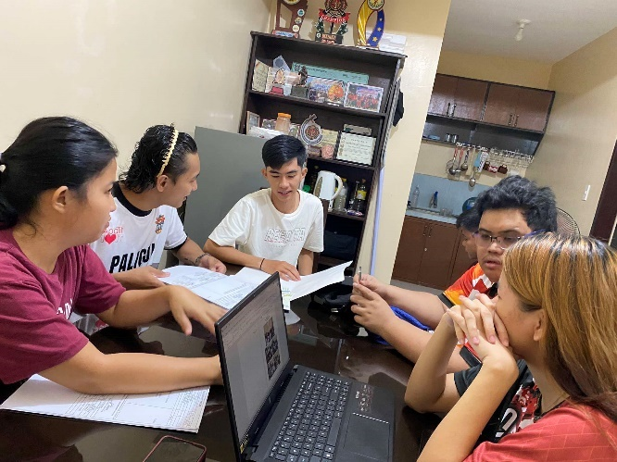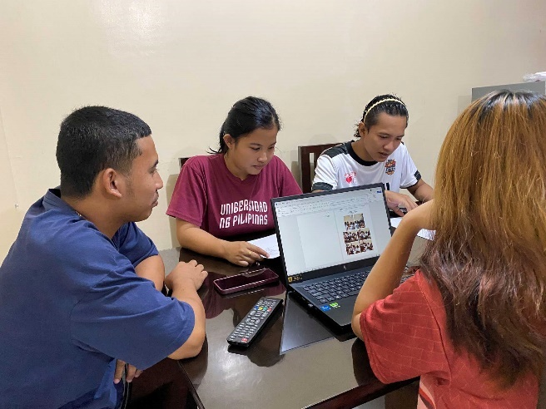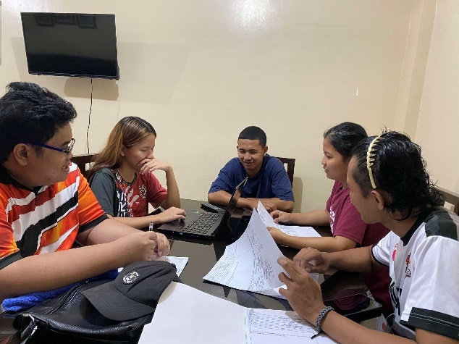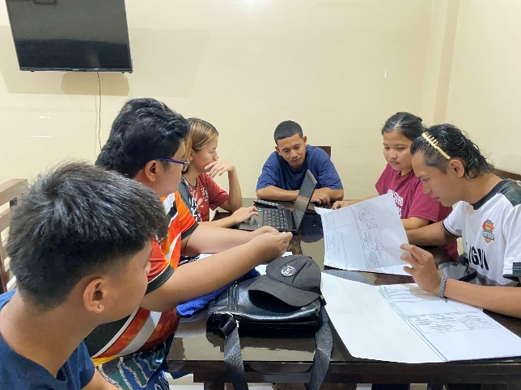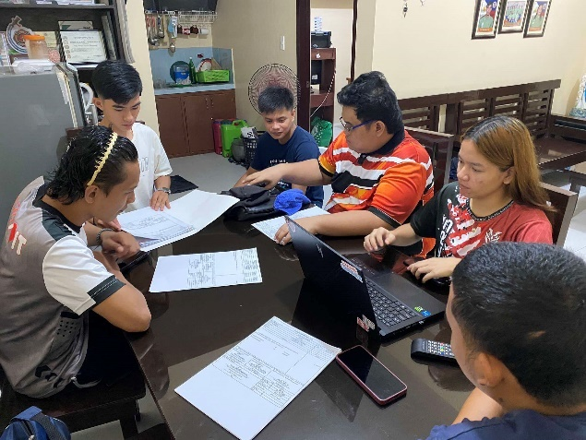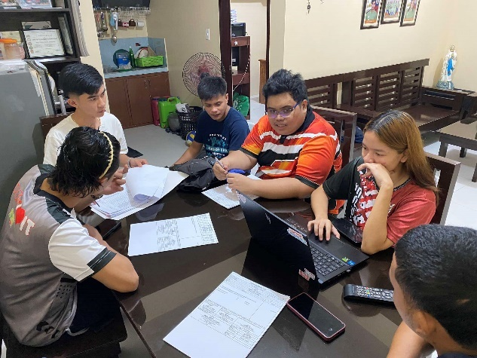

Republic of the Philippines

Region III

Province of Pampanga

Municipality of Apalit

**BARANGAY PALIGUI**

*Office of the Sangguniang Kabataan*

**Barangay Session 9**

**MINUTES OF THE MEETING**

Date: July 13, 2024

Time: 10:00 am

**AGENDA:**

1. Update of Educational Assistance
2. Update of Linggo ng Kabataan
3. Planning for Clean-up Drive
4. Other matters

**NAME POSITION**

**Present:**

Hon. Arjay L. Saclao - SK Chairperson/

Presiding Officer

Hon. Paul C. Alfonso - SK Kagawad

Hon. Ervie R. Dizon - SK Kagawad

Hon. Angelo F. Umali - SK Kagawad

Hon. Ian Jasper C. Villarico - SK Kagawad

Hon. Michaela Lorine R. Amparo - SK Kagawad

Mr. Kenneth D. Bautista - SK Secretary

Ms. Angel Mae B. Bautista - SK Treasurer

**Absent:**

Hon. Chin Jean M. Meneses - SK Kagawad

Hon. Karen B. Bautista - SK Kagawad

ORDER OF THE MEETING

1. SILENT Prayer was conducted and lead by SK Secretary Kenneth Bautista before the meeting started at 10:00 am in the morning.
2. Sk Kagawad Michaela Lorine Amparo give an update for Educational Assistance
3. Sk Kagawad Paul Alfonso give an update for Linggo ng Kabataan
4. Sk Kagawad Angelo Umali proceed to discussed the planning for Clean-up Drive
5. Sk Chairperson Arjay Saclao proceed to the other matters.
6. The preciding officer ajorned the meeting at 12:09 pm.

Prepared by:

Mr. Kenneth D. Bautista

SK Secretary

Noted by:

Hon. Arjay L. Saclao

SK Chairperson

Republic of the Philippines

Region III

Province of Pampanga

Municipality of Apalit

**BARANGAY PALIGUI**

*Office of the Sangguniang Kabataan*

**Barangay Session 9**

**MINUTES OF THE MEETING   
(DOCUMENTATION)**

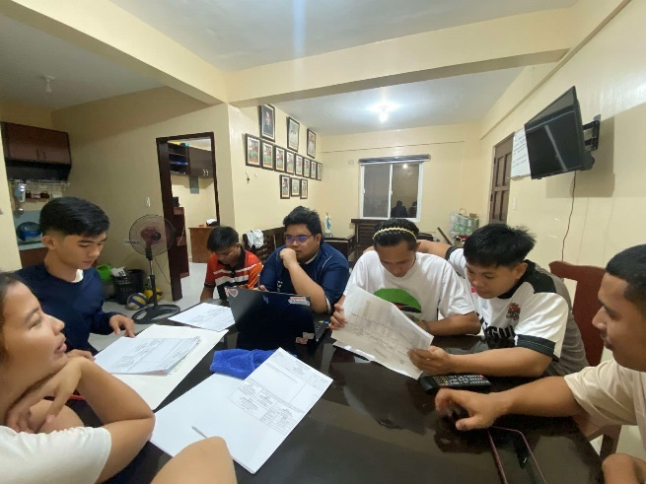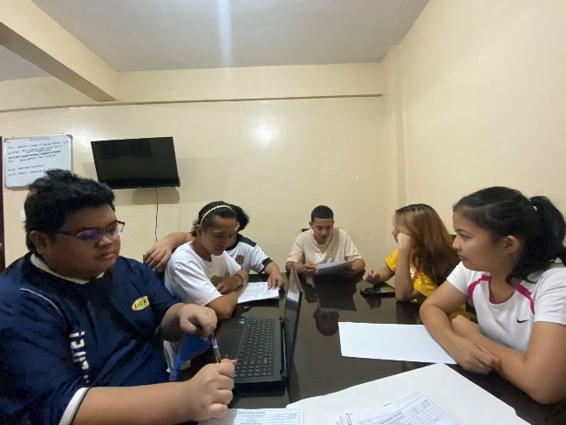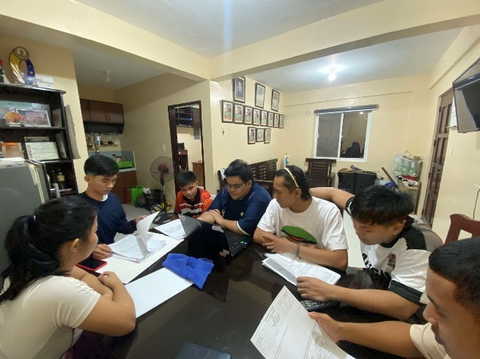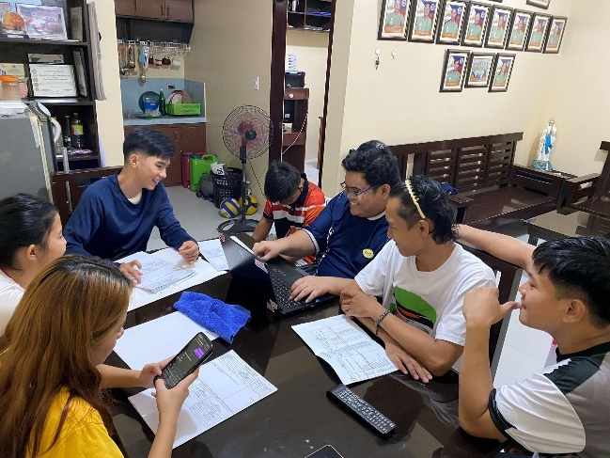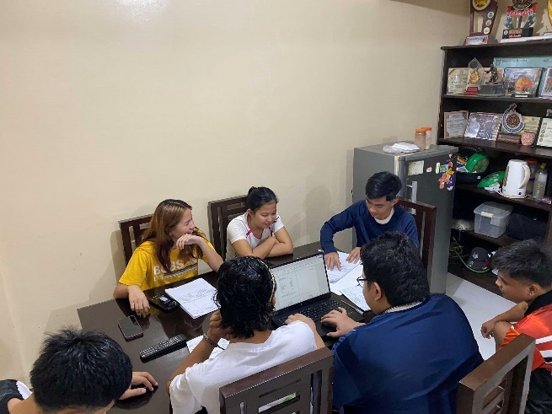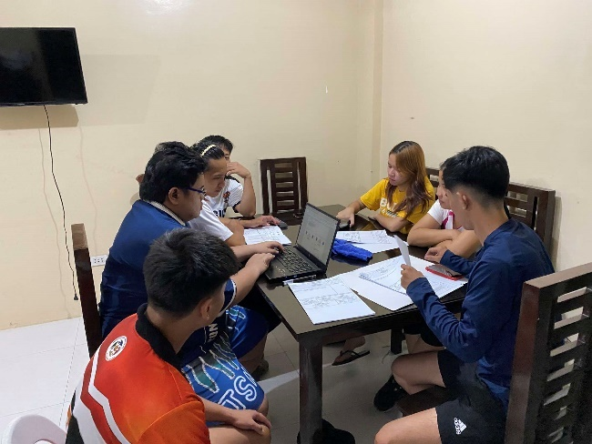

Republic of the Philippines

Region III

Province of Pampanga

Municipality of Apalit

**BARANGAY PALIGUI**

*Office of the Sangguniang Kabataan*

**Barangay Session 10**

**MINUTES OF THE MEETING**

Date: August 17, 2024

Time: 5:00 pm

**AGENDA:**

1. Linngo ng Kabataan
2. Budget Reallignment
3. Other matters

**NAME POSITION**

**Present:**

Hon. Arjay L. Saclao - SK Chairperson/

Presiding Officer

Hon. Paul C. Alfonso - SK Kagawad

Hon. Ervie R. Dizon - SK Kagawad

Hon. Angelo F. Umali - SK Kagawad

Hon. Ian Jasper C. Villarico - SK Kagawad

Hon. Michaela Lorine R. Amparo - SK Kagawad

Mr. Kenneth D. Bautista - SK Secretary

Ms. Angel Mae B. Bautista - SK Treasurer

**Absent:**

Hon. Chin Jean M. Meneses - SK Kagawad

Hon. Karen B. Bautista - SK Kagawad

ORDER OF THE MEETING

1. SILENT Prayer was conducted and lead by SK Kagawad Angelo Umali before the meeting started at 9:00 am in the morning.
2. Sk Kagawad Michaela Lorine Amparo give an update for Educational Assistance
3. Sk Kagawad Paul Alfonso give an update for Linggo ng Kabataan
4. Sk Kagawad Angelo Umali proceed to discussed the planning for Clean-up Drive
5. Sk Chairperson Arjay Saclao proceed to the other matters.
6. The preciding officer ajorned the meeting at 7:10 pm.

Prepared by:

Mr. Kenneth D. Bautista

SK Secretary

Noted by:

Hon. Arjay L. Saclao

SK Chairperson

Republic of the Philippines

Region III

Province of Pampanga

Municipality of Apalit

**BARANGAY PALIGUI**

*Office of the Sangguniang Kabataan*

**Barangay Session 10**

**MINUTES OF THE MEETING   
(DOCUMENTATION)**

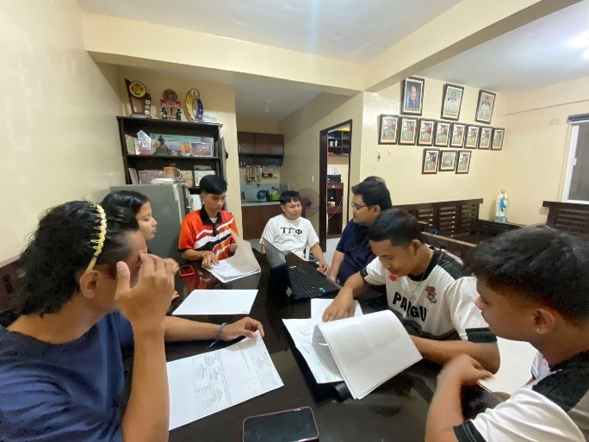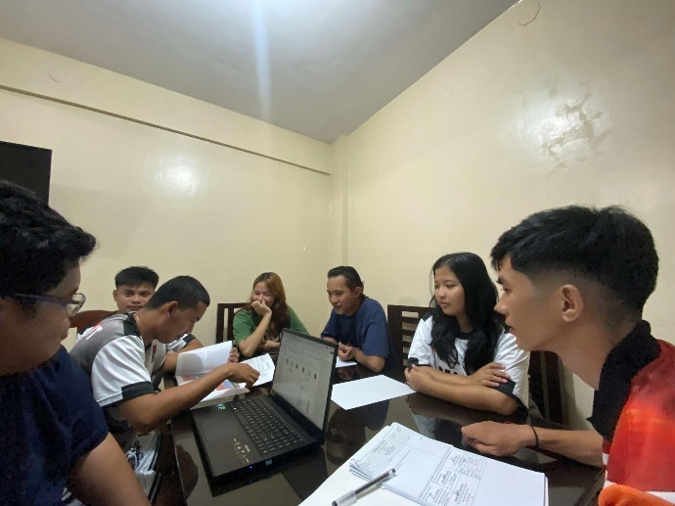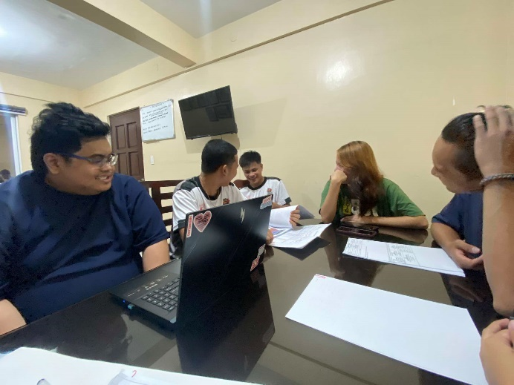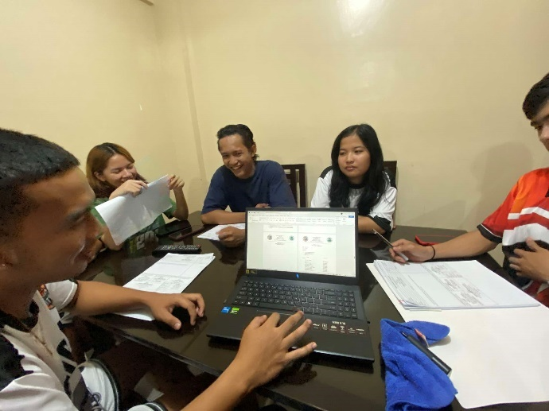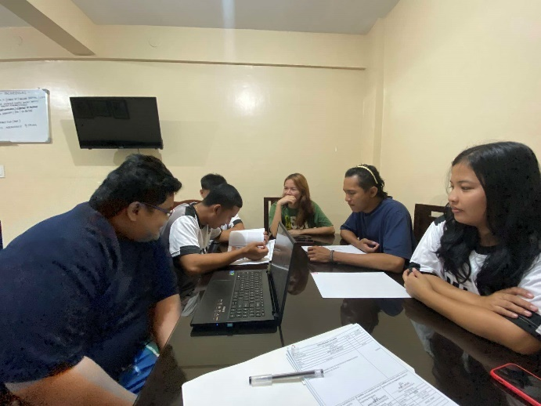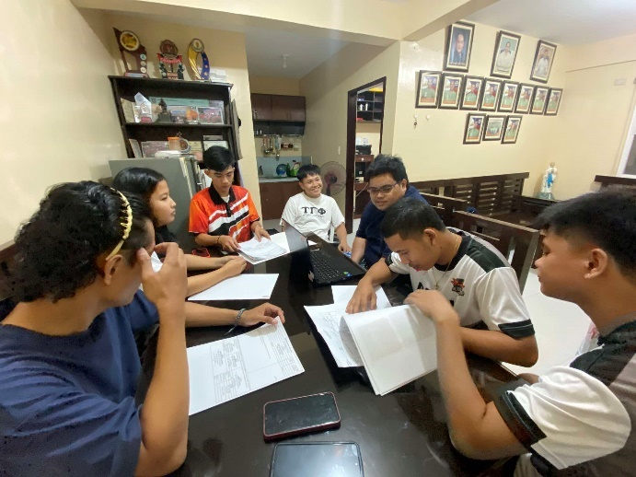

Republic of the Philippines

Region III

Province of Pampanga

Municipality of Apalit

**BARANGAY PALIGUI**

*Office of the Sangguniang Kabataan*

**Barangay Session 11**

**MINUTES OF THE MEETING**

Date: September 15, 2024

Time: 8:00 am

**AGENDA:**

1. Finalyze the list of scholars for Educational Asisstance
2. Preparation for MJDT’s Cup Volleyball League
3. Budget reallignment
4. Other matters

**NAME POSITION**

**Present:**

Hon. Arjay L. Saclao - SK Chairperson/

Presiding Officer

Hon. Paul C. Alfonso - SK Kagawad

Hon. Ervie R. Dizon - SK Kagawad

Hon. Angelo F. Umali - SK Kagawad

Hon. Ian Jasper C. Villarico - SK Kagawad

Hon. Michaela Lorine R. Amparo - SK Kagawad

Hon. Karen B. Bautista - SK Kagawad

Mr. Kenneth D. Bautista - SK Secretary

Ms. Angel Mae B. Bautista - SK Treasurer

**Absent:**

Hon. Chin Jean M. Meneses - SK Kagawad

ORDER OF THE MEETING

1. SILENT Prayer was conducted and lead by SK Treasurer Angel Mae Bautista before the meeting started at 9:00 am in the morning.
2. Sk Kagawad Michaela Lorine Amparo discussed the finalization of list of scholars for Educational Asisstance
3. Sk Chairperson discussed the preparation for the MJDT’s Cup Volleyball League
4. Sk Treasurer Angel Mae Bautista discussed the Budget realignment
5. Sk Chairperson Arjay Saclao proceed to the other matter
6. The preciding officer ajorned the meeting at 10:05 am.

Prepared by:

Mr. Kenneth D. Bautista

SK Secretary

Noted by:

Hon. Arjay L. Saclao

SK Chairperson

Republic of the Philippines

Region III

Province of Pampanga

Municipality of Apalit

**BARANGAY PALIGUI**

*Office of the Sangguniang Kabataan*

**Barangay Session 11**

**MINUTES OF THE MEETING   
(DOCUMENTATION)**

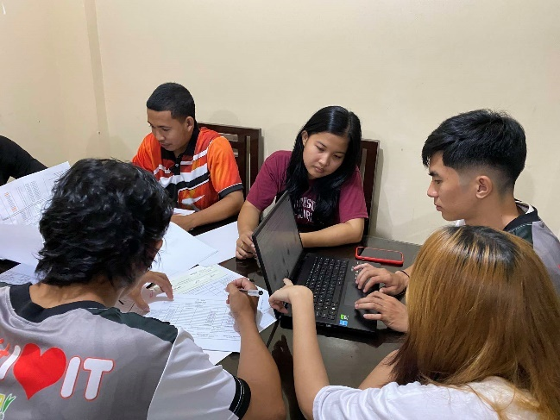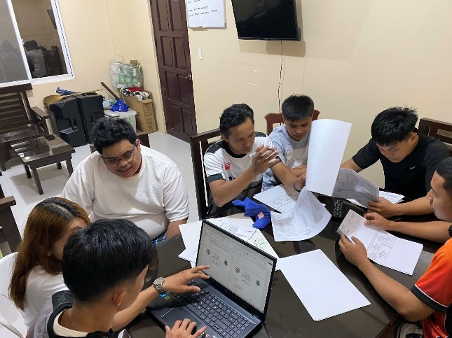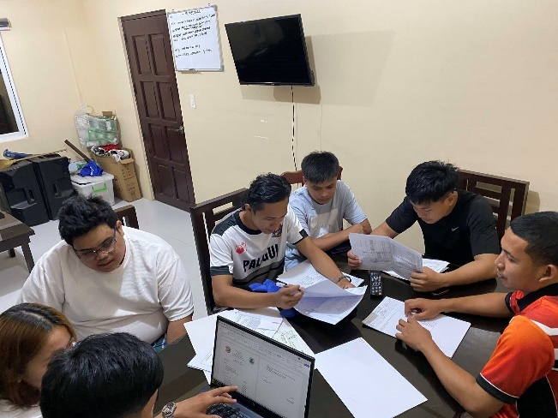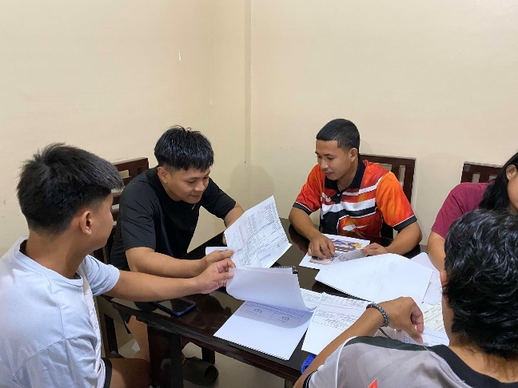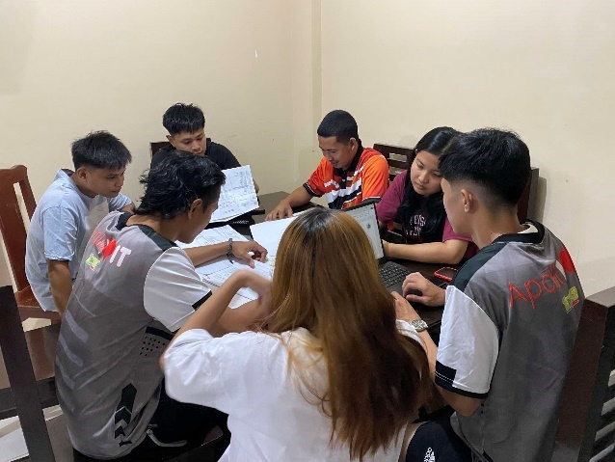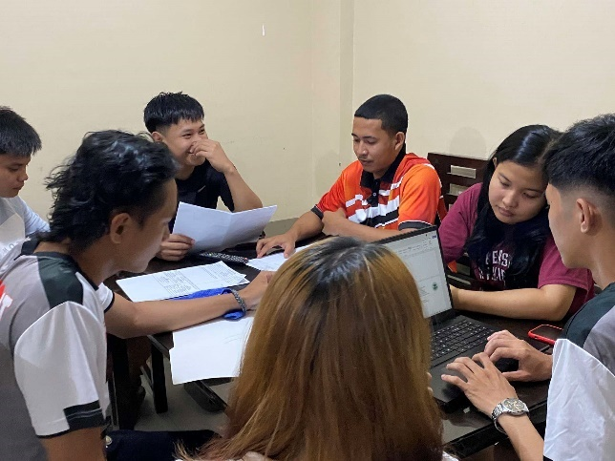

Republic of the Philippines

Region III

Province of Pampanga

Municipality of Apalit

**BARANGAY PALIGUI**

*Office of the Sangguniang Kabataan*

**Barangay Session 12**

**MINUTES OF THE MEETING**

Date: October 13, 2024

Time: 6:00 pm

**AGENDA:**

1. Planning for the distribution of Educational Asisstance
2. Update for MJDT’s Cup Volleyball League
3. Clean-up Drive
4. Budget realignment
5. Katipunan ng Kabataan Assembly
6. Barangay Assembly
7. Other matters

**NAME POSITION**

**Present:**

Hon. Arjay L. Saclao - SK Chairperson/

Presiding Officer

Hon. Paul C. Alfonso - SK Kagawad

Hon. Ervie R. Dizon - SK Kagawad

Hon. Angelo F. Umali - SK Kagawad

Hon. Ian Jasper C. Villarico - SK Kagawad

Hon. Michaela Lorine R. Amparo - SK Kagawad

Hon. Karen B. Bautista - SK Kagawad

Mr. Kenneth D. Bautista - SK Secretary

Ms. Angel Mae B. Bautista - SK Treasurer

**Absent:**

Hon. Chin Jean M. Meneses - SK Kagawad

ORDER OF THE MEETING

1. SILENT Prayer was conducted and lead by SK Kagawad Michaela Lorine Amparo before the meeting started at 6:00 pm in the morning.
2. Sk Kagawad Michaela Lorine Amparo discussed the planning for the distribution of scholars for Educational Asisstance
3. Sk Chairperson Arjay Saclao give an update for the MJDT’s Cup Volleyball League
4. Sk Secretary Kenneth Bautista proceed to discussed the Katipunan ng Kabataan Assembly
5. Sk Chairperson Arjay Saclao announced the schedule for upcoming Barangay Assembly
6. Sk Arjay Saclao proceed to the other matters
7. The preciding officer ajorned the meeting at 5:54 pm.

Prepared by:

Mr. Kenneth D. Bautista

SK Secretary

Noted by:

Hon. Arjay L. Saclao

SK Chairperson

Republic of the Philippines

Region III

Province of Pampanga

Municipality of Apalit

**BARANGAY PALIGUI**

*Office of the Sangguniang Kabataan*

**Barangay Session 12**

**MINUTES OF THE MEETING   
(DOCUMENTATION)**

